Some specs for Ecommerce Ver 1.0

Some similar ecommerce sites to follow for features:

1. [www.umart.com.au](http://www.umart.com.au)
2. [www.pccasegear.com](http://www.pccasegear.com)
3. [www.gocomp.com.au](http://www.gocomp.com.au)

# Home Page Layout

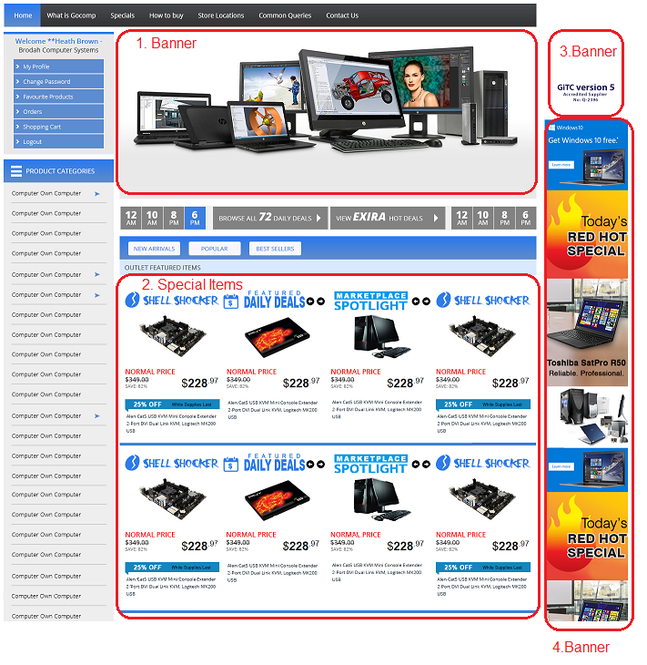

## 1. Banner

Banner should have option to put either one full height banner or 2 x half height banners

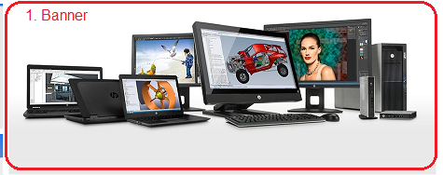

2 x half height banners:



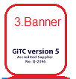

# 2. Special Items

These are of 4 types:

### Shell Shocker, Daily Deal, Marketplace Spotlight, Manager’s Special



Items Table in MySQL will have the above fields which relate to the special item types.

Value = 1 means item is special.

Position will have the values 1, 2, 3, 4…

Each row will have items of same category.

i.e. 1st row may have NOTEBOOKS

2nd row may have HARD DRIVES

3rd row may have MOTHERBOARDS etc.

Normal Price = MySQL Retail Price inc. GST (column AH)

SAVE% = [(NORMAL PRICE – INTERNET PRICE)/NORMAL PRICE ] x 100

SAVE% = % OFF While Stock Last ---🡪 

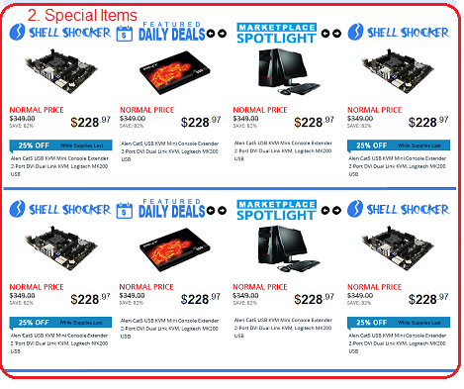

# PRODUCT PAGE layout

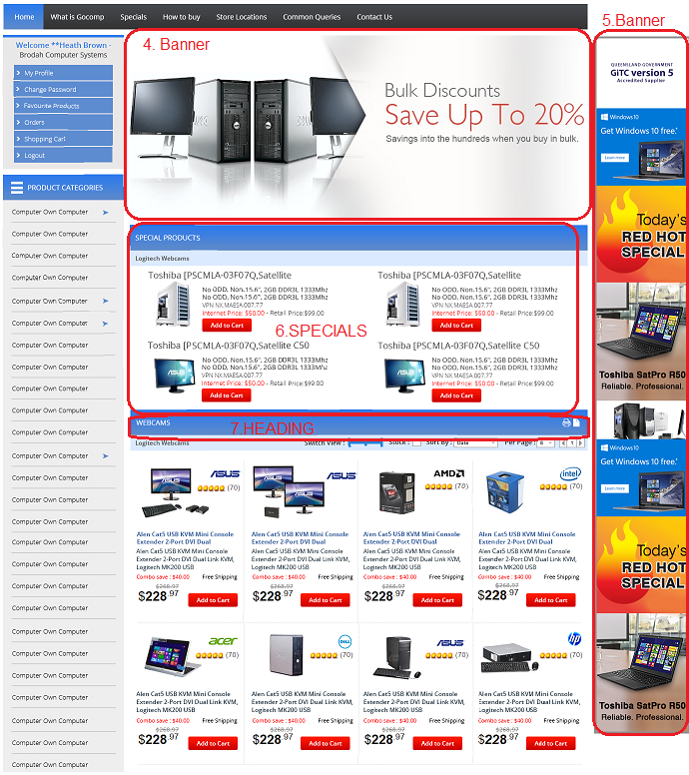

## 4. Banner

Every Product Menu from left panel will have an option to place a unique banner from admin panel

– option for 1 full height banner or 2 x half height banners

## 5. Banner

Every Product Menu from left panel will have an option to place a unique banner from admin panel.

If no banner is uploaded it should show the same banner as in Home Page

## 6. SPECIALS

Specials relating to the category on display should show here.

Means if the page is for Wired Keyboards, then if there are any items special in this category they should show here.

## 7. HEADING

There may be any number of headings in a page

Each heading has an associated sql query which creates an item list. Eg.:

HEADING = Wired Microsoft Keyboards

QUERY = **CATEGORY = “KBD” AND BRAND = “MSF” AND M1 = “WIRED”**

These will be created in admin panel as below:

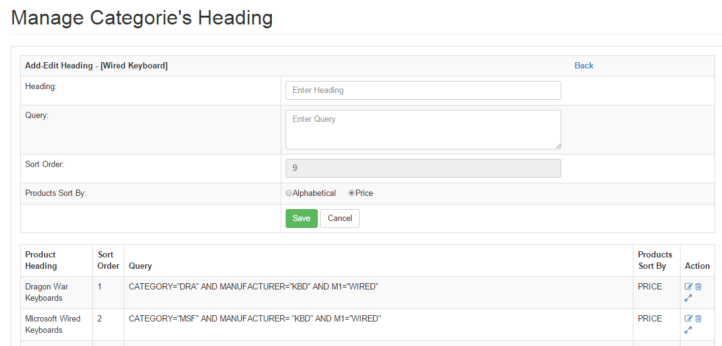

## 8. Keyword Search

Keyword Search on Home Page

See [www.pccasegear.com](http://www.pccasegear.com),

[www.synnex.com.au](http://www.synnex.com.au) login = auscompcom. Pwd = akash1809

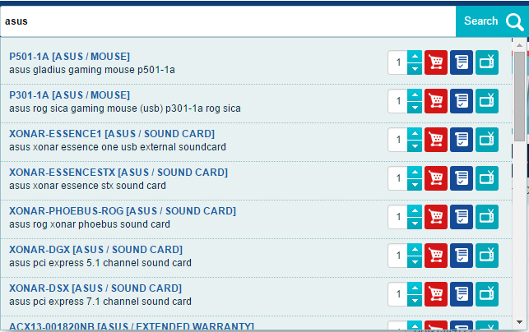

Autofill, Result load speed <1sec

## 9. Advanced Search

See <http://www.auscompcomputers.com/advance_search>

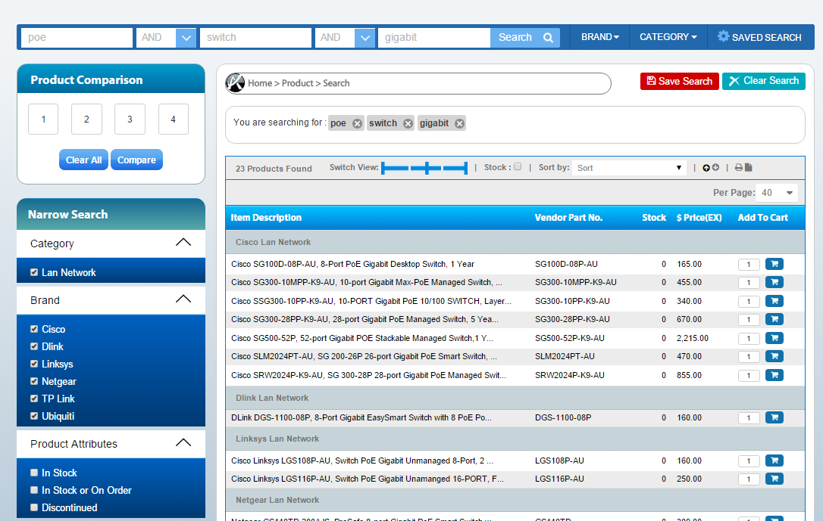

## 10. Chat Helper

## 11. Social Media Integration

<http://www.sharethis.com/get-sharing-tools/#sthash.ORY0QZIk.dpbs>

## 11. New User Signup

Login with Facebook etc.

Provide captcha

## 12. Custom Computer Build (Design your own computer)

See <http://www.umart.com.au/umart1/pro/build_computer1.phtml?id=10&bid=2&id2=9>

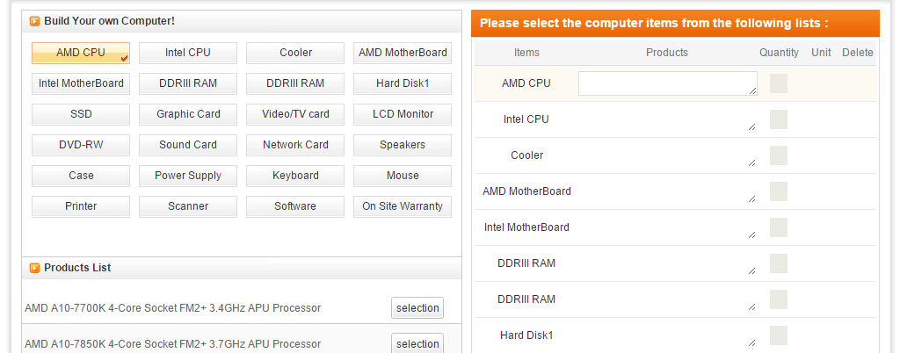

# Admin Panel

## Product Headings

Check [www.gocomp.com.au/administrator](http://www.gocomp.com.au/administrator)

There may be any number of headings in a page

Each heading has an associated sql query which creates an item list. Eg.:

HEADING = Wired Microsoft Keyboards

QUERY = **CATEGORY = “KBD” AND BRAND = “MSF” AND M1 = “WIRED”**

These will be created in admin panel as below:



## Product List

* List all Products for product specs, image manipulation.
* Filter by all fields in Item table.
* Edit all the fields for Item Table here

## Manage Specials

Set Item as one of the 4:- Shell Shocker, Daily Deal, Marketplace Spotlight, Manager’s Special using an admin panel such as below:

Check [www.auscompcomputers.com/admin/hotspecial](http://www.auscompcomputers.com/admin/hotspecial)

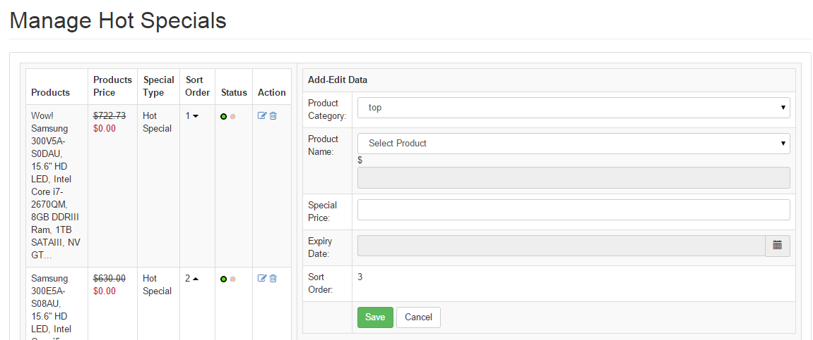

## Manage Banners

## Manage home page News content

## Google Analytics panel

## User Registration and Management

## Manage Website Admin Users

## Manage Prebuilt Systems

See [www.gocomp.com.au](http://www.gocomp.com.au) admin panel at

<http://www.gocomp.com.au/administrator/index.php?cpath=prebuiltcomputercategories>

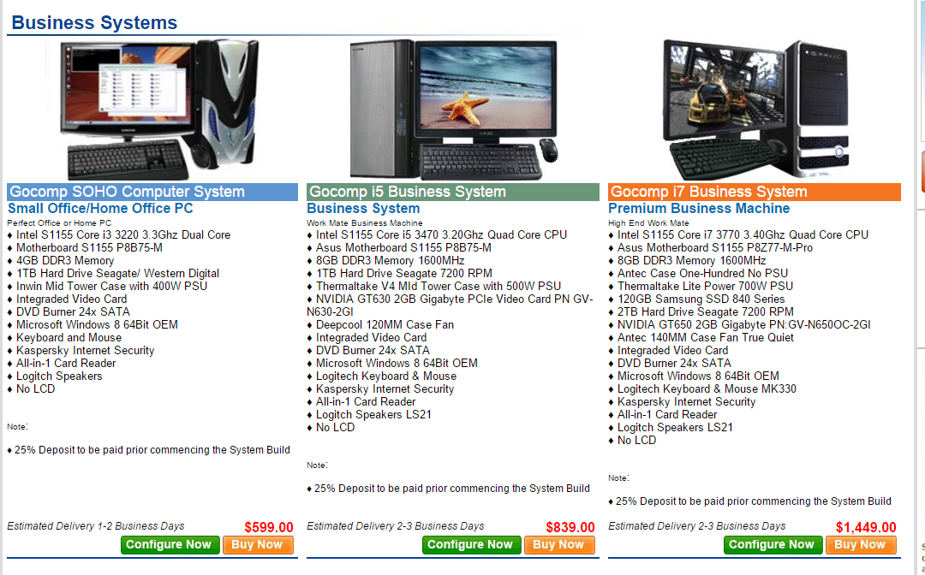

Admin Panel

<http://www.gocomp.com.au/administrator/index.php?cpath=computersystems&action=edit&cid=269&pid=269&id=271&systemid=3>

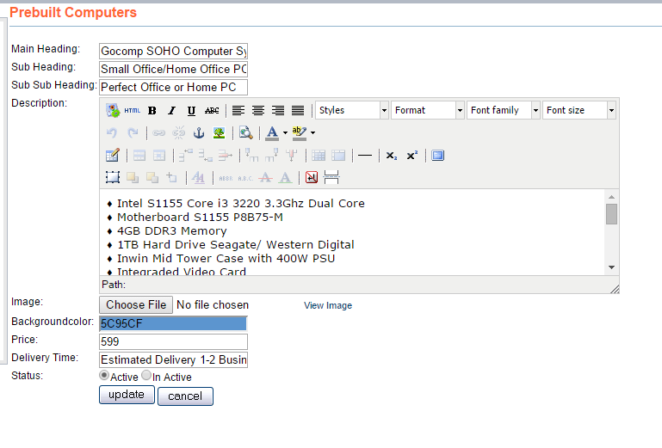

## Ebay/Amazon Store Integration

<http://www.magentocommerce.com/magento-connect/ebay-magento-integration-order-import-and-stock-level-synchronization-also-supports-amazon-rakuten.html>

## **eBay-Magento Integration - Order Import and Stock Level Synchronization. Also supports Amazon, Rakuten**

[The **M2E Pro** extension fully integrates Magento into eBay, Amazon and Rakuten platform](http://www.m2epro.com/). This allows quick and simple creation as well as management of product listings (inc. automated synchronization of stock levels, pricing, and product details), import of eBay/Amazon/Rakuten order, automated feedback posting for buyers and many other tasks which significantly reduce time required for listing maintenance.

The extension interacts with all 23 major eBay, 7 Amazon and 2 Rakuten (USA at the moment) marketplaces. It supports multiple eBay/Amazon/Rakuten accounts and multiple Magento stores.

The M2E Pro listings are based on 3 types of templates: **Selling Format**, **Description** and **General** which provides flexibility and minimizes efforts.

* **Selling Format Template** contains information about listing types, quantities, auction duration and specifies price-related data (including that of Best Offer).
* **Description Template** sets products “look and feel”.
* **General Template** contains basic settings which are required for successful eBay listing.

The listing data synchronization between Magento and eBay is governed by **Synchronization Template**.

The **Activation / Deactivation Actions, Revise, Relist** and **Stop** rules within templates support implementation of numerous synchronization strategies that can be applied to relevant listings. (i.e. multiple updates: quantity, price, title, description for some items while only quantity for others.) Furthermore it is possible to **schedule** product actions (**list, relist**) on eBay.

User friendly interface delivers: simpleoverview, **“one click” & “bulk”**management (i.e. **revise, relist, and stop**) of listed eBay items, quick navigation to those items placed on eBay and products association in Magento store.

Besides managing items listed by M2E Pro, the extension fully supports (**relist, stop**) actions for products listed by any other tool (eBay, ChannelAdvisor, Auctiva, TurboLister, etc).

The most important feature of the extension is the ability to import **eBay Transactions** and to create **Magento Orders**. As far as order management, the extension treats eBay originated orders as regular Magento orders.

Order fulfillment process is reflected on eBay. (i.e. when shipment is created, an eBay order gets “Shipped” status. If a shipment has a tracking number, it is also posted to eBay).

There are flexible settings **for eBay Transactions** and **Customer** importing, which can be set for each eBay account individually.

It is possible to maintain a mapping between eBay Order status and Magento Order statuses. Another useful feature allows products that are sold only on eBay to be imported later into Magento catalog for order processing.

Additionally plug in has the ability to enable **auto- response** for buyers’ feedbacks using the predefined response templates. Those feedbacks settings and templates also can be set for each eBay account individually. Depending on settings auto responses can be sent either for Positive feedbacks or for any other feedback type.

There are various **global configuration** options. It is possible enable/disable certain synchronization globally - for all eBay accounts at one place. Also there are options, which allow enable/disable useful notifications (i.e when cron job is not run for last 12 hours or new negative feedback was received from buyer). In the Marketplaces section, you can enable eBay Marketplaces you will work with.

There are various global configuration options available: not limited to synchronization for multiple eBay accounts (i.e. one point of entry), notifications (enable/disable) management (i.e cron job delay or negative feedback alert).

**Marketplaces** section allows activation of any of eBay Marketplaces.

Finally the extension has excessive logging:

* **Listings Log** – provides full information about listings during their life cycle (creation, addition to a catalog, listing on eBay, product related changes (price, quantity, etc), actions (Revise, Stop, Relist, Delete Item(s), eBay notifications, Listing deletions, etc.).
* **3rd Party Listings Log** – contains full information on 3rd Party Listings during their life cycle. (Import of 3rd Party Listings from eBay, 3rd Party Listings actions (Stop, Relist), eBay notifications, etc.).
* **Synchronizations Log** – contains Templates, Orders, Feedback and 3rd Party Listings Synchronization related errors.

Users, if necessary, are able to automatically clean log files.

Once you have your store in place, management of your eBay ‘channel’ is relatively simple, allowing you to concentrate of fulfilling your orders!

* Setup templates to manage eBay listings automatically
* List auctions with a delayed start for optimal end time
* Maintain one core set of inventory for your online store and eBay
* Automatically stop listings when out of stock, an item becomes disabled or for other triggers
* Automatically update product detail and inventory level changes
* Automatically manage feedback
* Automatically import orders and customers into your online store
* Autmoatically post tracking data to eBay
* Batch process eBay items - list, review, relist, stop
* Manage dispatch centrally
* Australia Post integration available
* Professional, branded tax invoices
* Professional, branded communication sent to buyers through your online store
* Save money on alternative bulk listing methods - Magento eBay integration is free!

## On Page SEO

## Dashboard (this is screen dump from Magento demo. Only as reference)

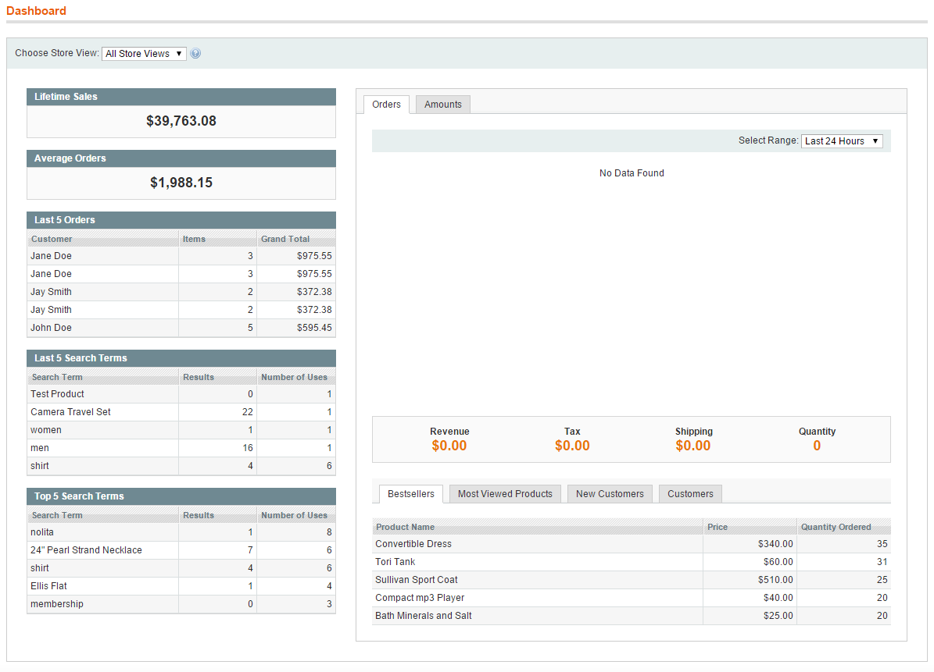

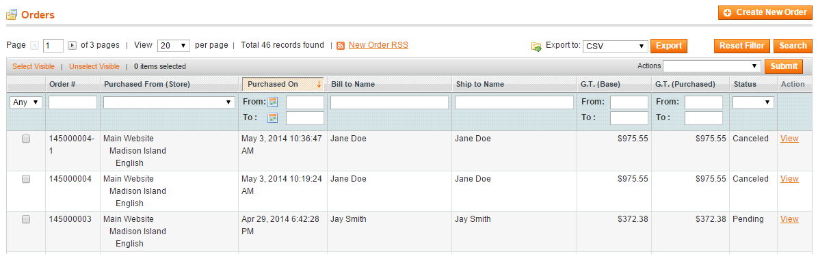

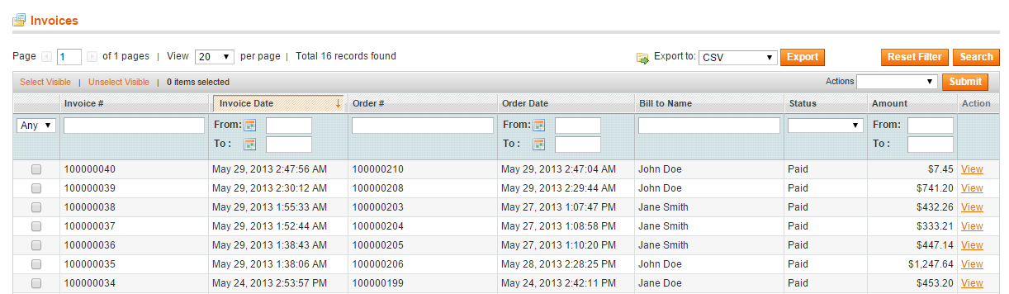

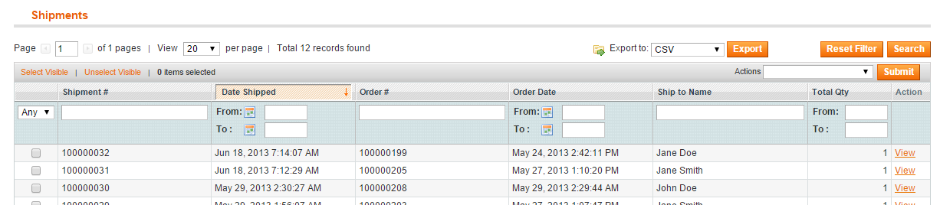

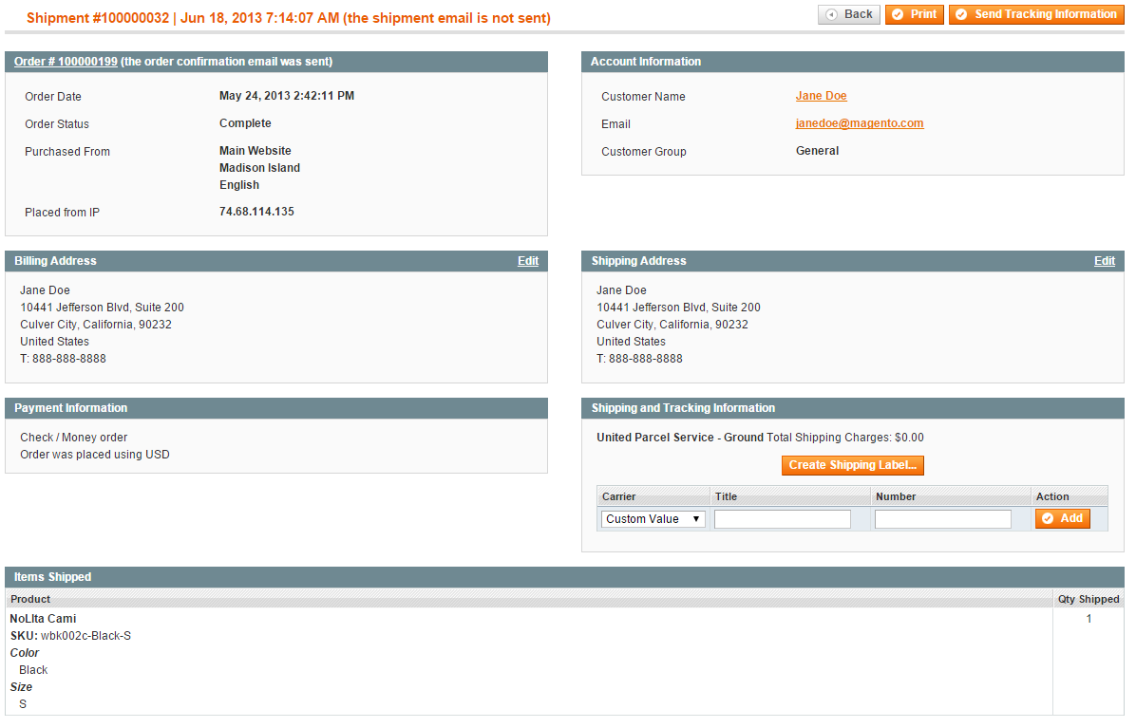

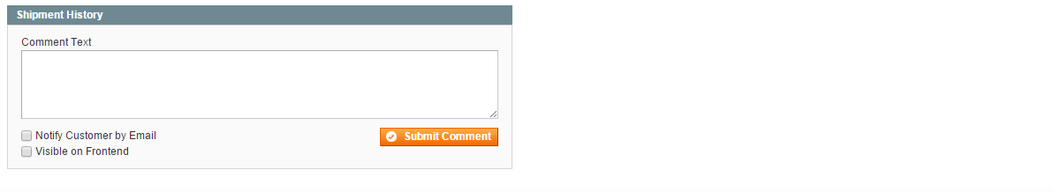

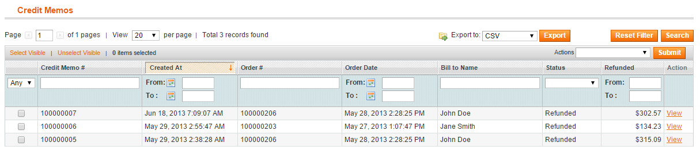

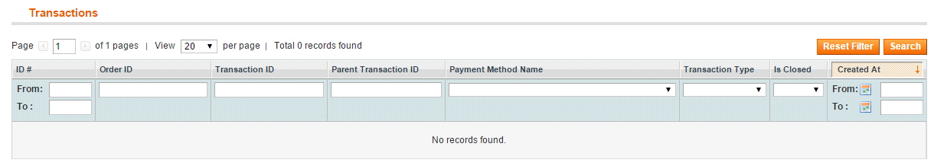

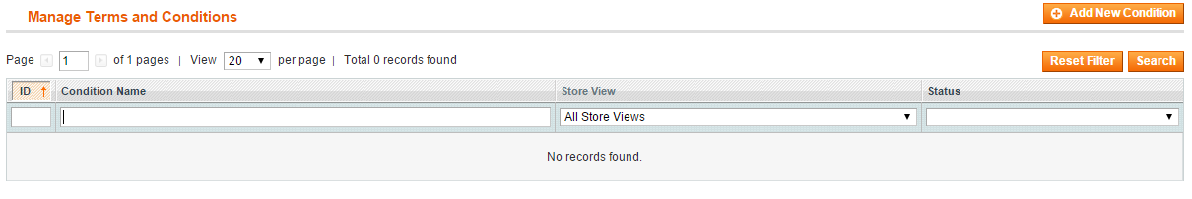

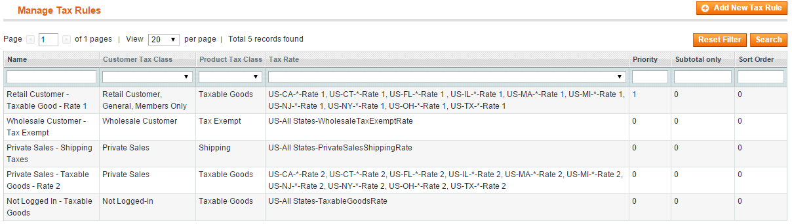

## Catalog

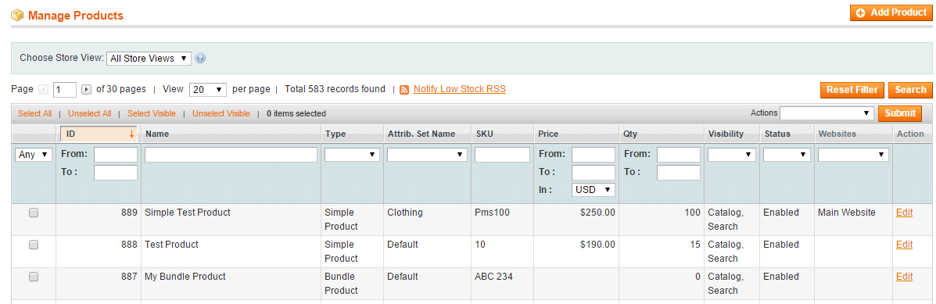

Edit Product

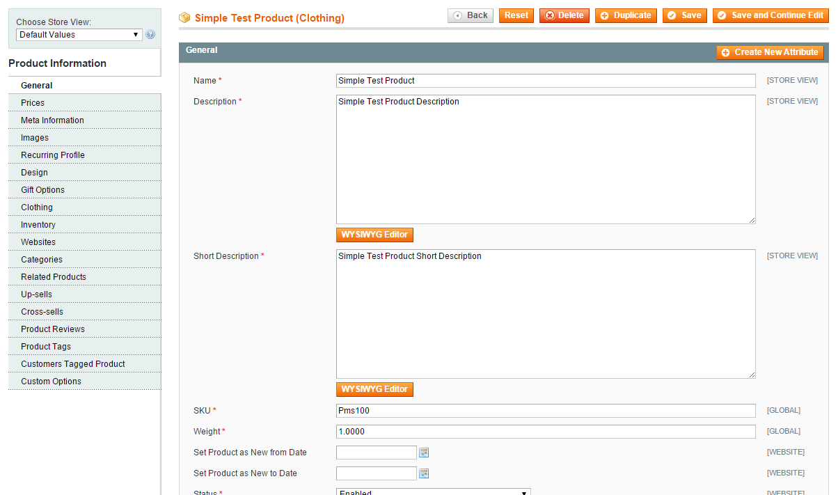



Categories

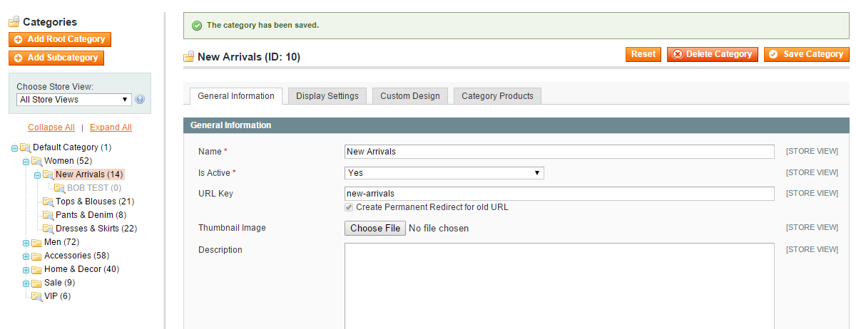

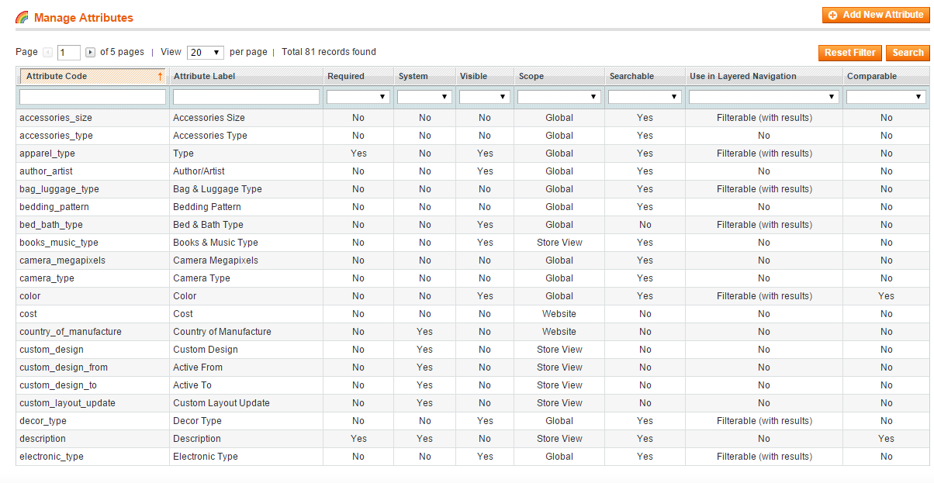

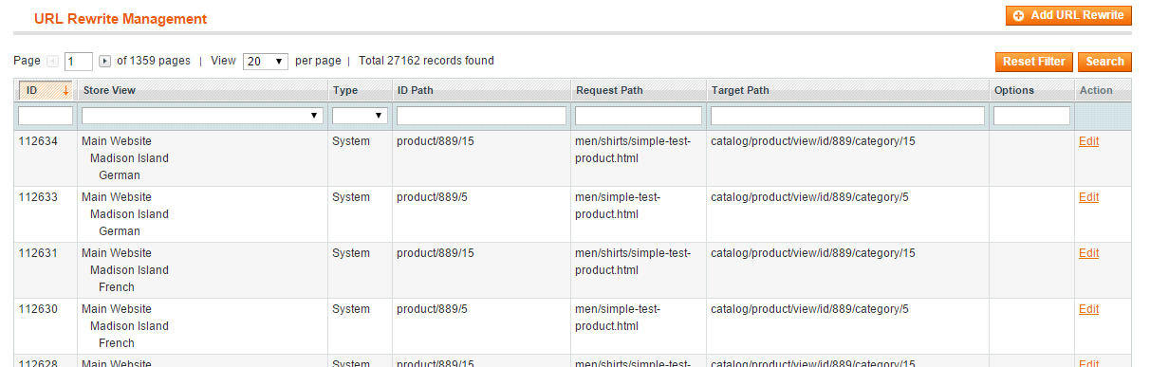

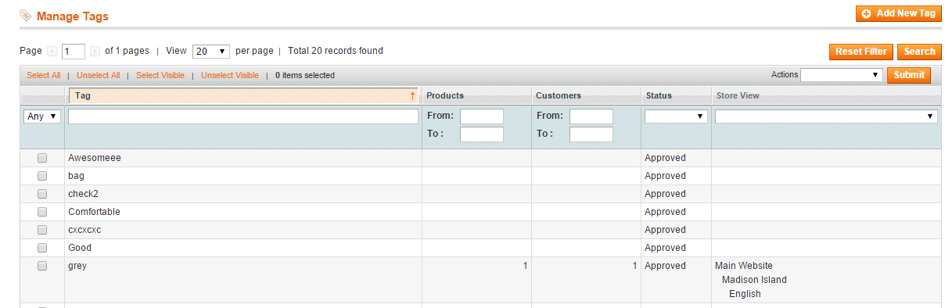

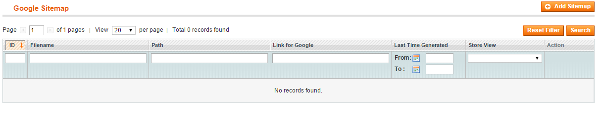

## Customers

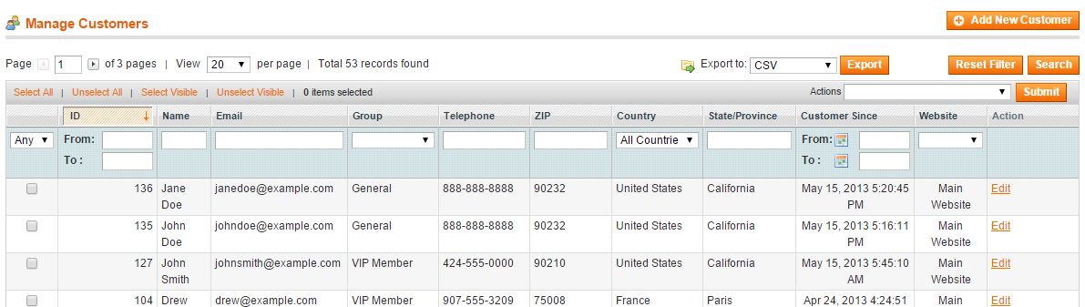

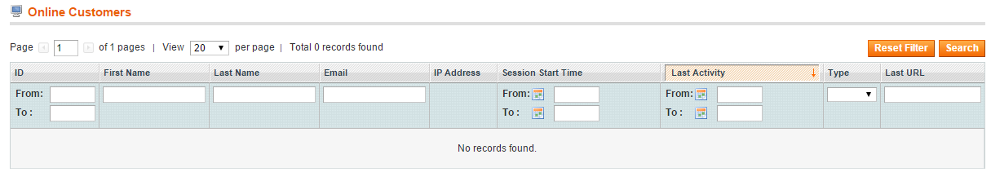

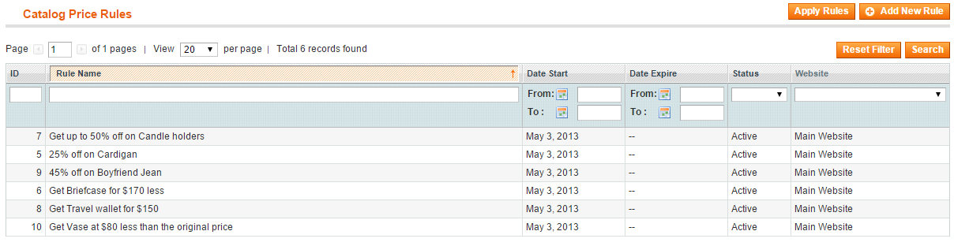

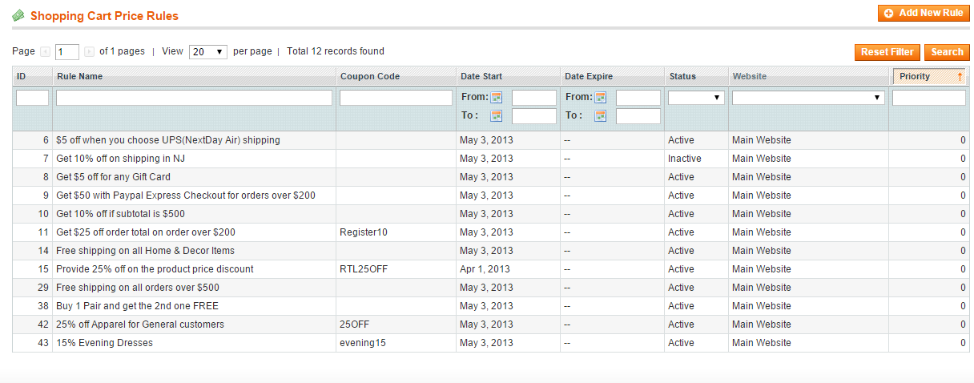

## Newsletter

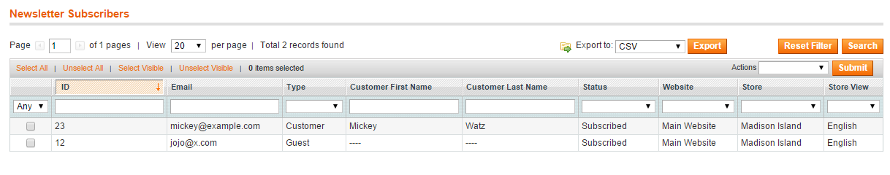CMS

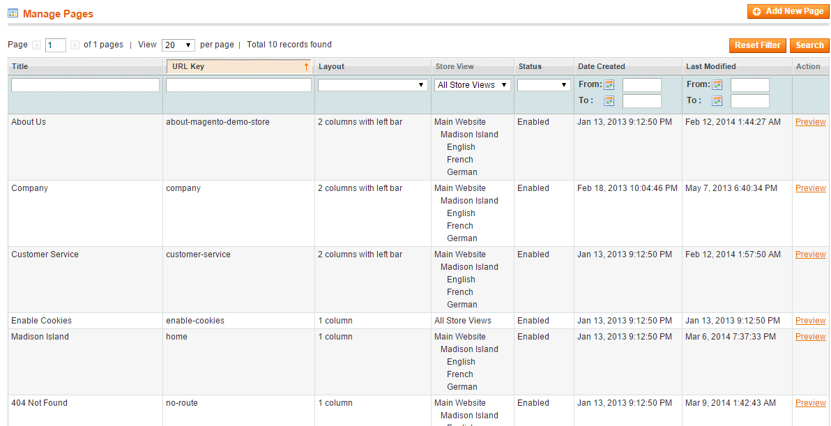

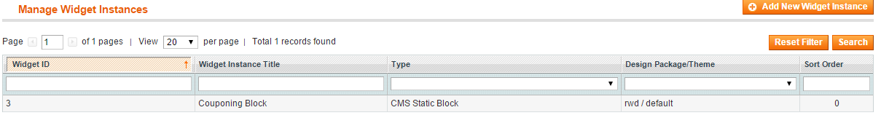

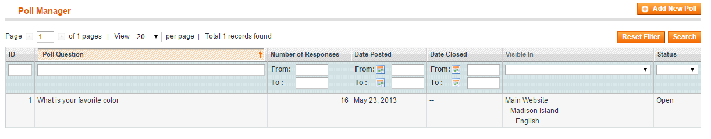

## Reports

